Apply SQL JOIN

Project description

The management at my organization has asked me to investigate potential security issues and
update employee computers as required. As a Linux administrator, I used SQL with filters to
perform security-related tasks. But for this scenario, I applied SQL join to play with the values
of the two tables. This task is related to relational database management.

Inner Join

I created a SQL query on MariaDB to join two tables focusing on the intersection of two tables,
where we only care about rows that have corresponding values in both.

This is the “employees” table.
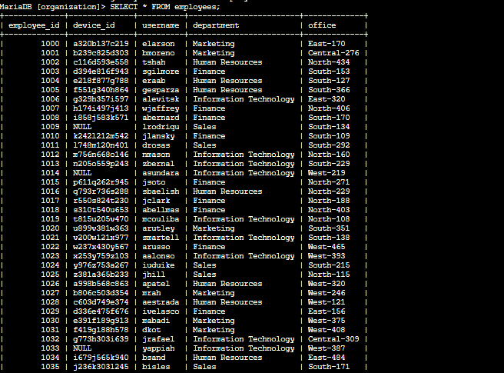
This is the query that produces username, operating system, and employee ID from both
tables. The username is from one of the tables and so is the operating system. For the table
that can be found on both, we use “table.column” format to avoid ambiquity. In this case it is
the employee table (employee ID). As the result goes, there are 185 usernames with respective
operating systems and device IDs. Other variations can be found in the next pages of Inner
Join.
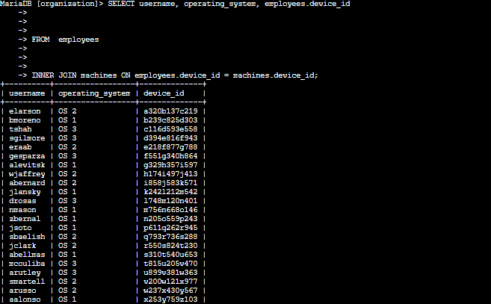
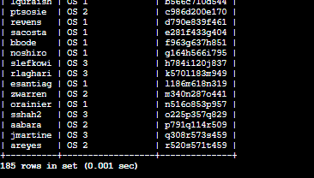

This query will produce username, employee ID, operating system, device ID and their
respective office.
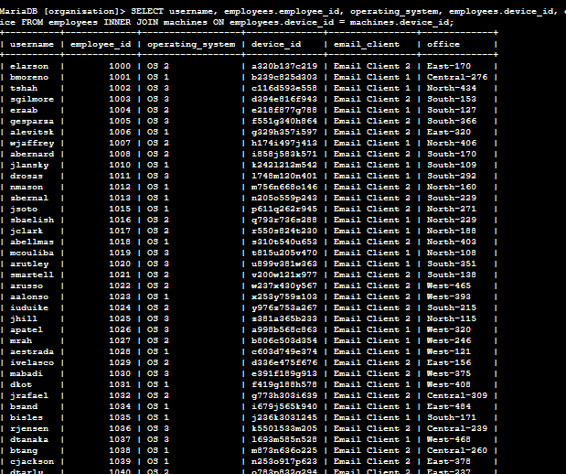
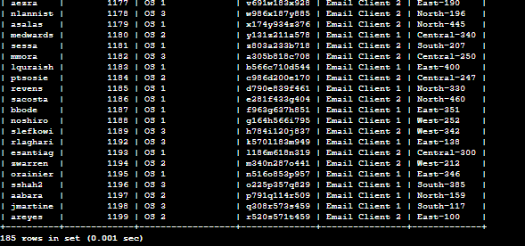

Return More Data

Left Join. The results will include all records from one or the other table. Here, I have to link
these tables using the common device_id column. In a left join, all records after FROM and
before LEFT JOIN are included in the result. In this case, all records from the machines
table are included, whether they are assigned to the employees table or not.
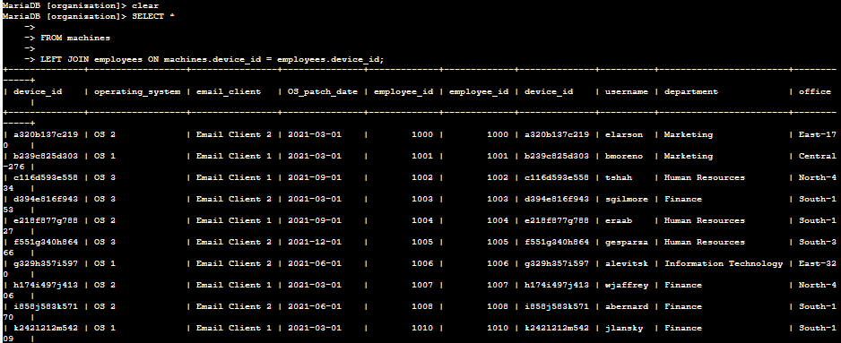
Right Join.
Right Join. The results will include all records from one or the other table. Here, I have to link
these tables using the common device_id column. In a right join, all records after RIGHT
JOIN are included in the result. In this case, all records from the employees table are

included, whether they have values on the machine table or not.
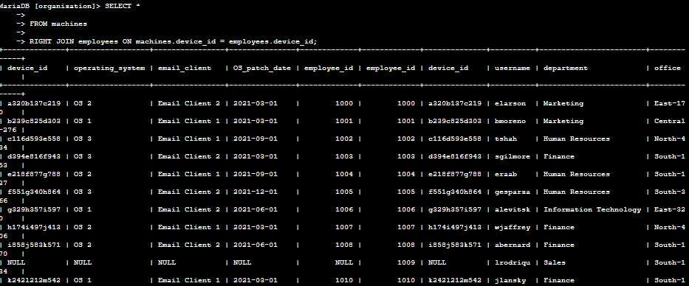
Both produced 200 rows each, however in the process, some data are written NUL due to
types of JOIN.

Summary
I wrote queries to join two tables in three different scenarios: Inner Join, Left Join, and Right
Join.

